

**North South University**

**Department of Electrical & Computer Engineering**

**LAB REPORT**

**Analog Electronics Lab**

**EEE111L**

**Experiment Number:** 1

**Experiment Name:** I-V Characteristics of Diode

**Experiment Date:** 25/10/2021

**Report Submission Date:** 1/11/2021

**Section:** 7 **Group No:** 2

**Students Name & ID:**

1. Md. Rifat Ahmed – 1931725042 **(Report Writer)**
2. Yusuf Abdullah Tonmoy – 1620456042
3. Md Kawser Islam - 1912296642

|  |  |  |
| --- | --- | --- |
| **Remarks:** | Score |  |
|  |  |
|  |  |  |
|  |  |  |

**Objectives:**

• Our objective in this experiment is to study the I-V characteristics of diode.

**Theory:**

A diode is an electrical component that allows current to flow in only one direction. This is a bipolar device that acts like a short circuit for a forward bias and like an open circuit when biased backwards. The most common type of diode is a PN junction. In this type of diode, the material (N), whose electrons are charge carriers, is adjacent to the second material (P) of, and its holes (where the electrons that function as positively charged particles are depleted). Acts as a charge carrier. A depletion region is formed at the interface, on which electrons diffuse to fill the p-side hole. This stops the flow of more electrons.

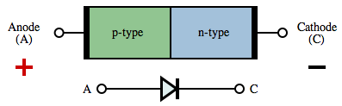

Figure: Diode

There are 2 types of biasing conditions for a diode. Those are given below:

1. **Forward biased condition:** When this junction is forward biased (a positive voltage is applied to the P-side), electrons can easily move across the junction to fill the holes, and current flows through the diode.

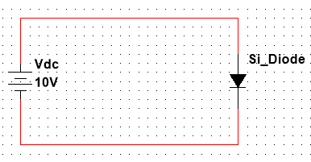

Figure: Forward Biased connection

1. **Reverse biased condition:** When the junction is reverse biased (a negative voltage is applied to the P-side), the depletion region widens and electrons cannot easily move across. The current remains very small until a certain voltage (the breakdown voltage) is reached and the current suddenly increases.

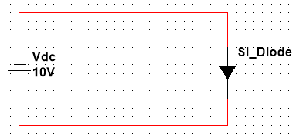

Figure: Reverse Biased connection

**Threshold Voltage:** The minimum voltage required for a diode to conduct current is called its Threshold Voltage. The Threshold voltage differs from diode to diode and generally the threshold for the diode we’re using, the silicone diode is 0.7V.

**Load Line:** A circuit supplied with dc power as the external source of the circuit. There exist both alternating and direct currents in the circuit. The reactive components of the circuits are made zero and the straight line is drawn above the voltage-current characteristics curves. Hence these results in the formation of intersecting point referred to an operating point. The straight that is drawn for this purpose is defined as the DC load line.

**Equipment List:**

• p-n junction diode (1N4007) – 1 piece

• Resistor (1kΩ) – 1 piece

• DC power supply

• Digital Multimeter

• Cords and wires

**Circuit Diagram:**

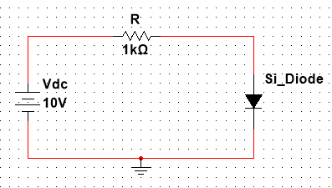

Figure – 1: Circuit diagram of forward biased diode

**Data & Table:**

Theoretical Value: R = 1kΩ

Measured Value: R = 1kΩ

|  |  |  |  |
| --- | --- | --- | --- |
| **Vdc**  **(volt)** | **Vd**  **(volt)** | **VR**  **(volt)** | **Id = VR / R**  **(mA)** |
| 0.1 | 0.1V | (0.1-0.1)V = 0V | 0 mA |
| 0.3 | 0.3V | (0.3-0.3)V = 0V | 0 mA |
| 0.5 | 0.498V | (0.5-0.498)V = 0.002V | 0.002 mA |
| 0.7 | 0.596V | (0.7-0.596)V = 0.104V | 0.104 mA |
| 0.9 | 0.622V | (0.9-0.622)V = 0.278V | 0.278 mA |
| 1 | 0.629V | (1 -0.629)V = 0.371V | 0.371 mA |
| 2 | 0.663V | (2-0.663)V = 1.337V | 1.337 mA |
| 3 | 0.677V | (3-0.677)V = 2.323V | 2.323 mA |
| 4 | 0.686V | (4-0.686)V = 3.314V | 3.314 mA |
| 6 | 0.698V | (6-0.698)V = 5.302V | 5.302 mA |
| 8 | 0.706V | (8-0.706)V = 7.294V | 7.294 mA |
| 10 | 0.713V | (10-0.713)V = 9.287V | 9.287 mA |
| 12 | 0.718 | (12-0.718)V = 11.282V | 11.282 mA |
| 14 | 0.722V | (14-0.722)V = 13.278V | 13.278 mA |
| 16 | 0.726V | (16-0.726)V = 15.274V | 15.274 mA |
| 18 | 0.729V | (18-0.729)V = 17.271V | 17.271 mA |
| 20 | 0.732V | (20-0.732)V = 19.268V | 19.268 mA |

Table - 1

**Graph:**

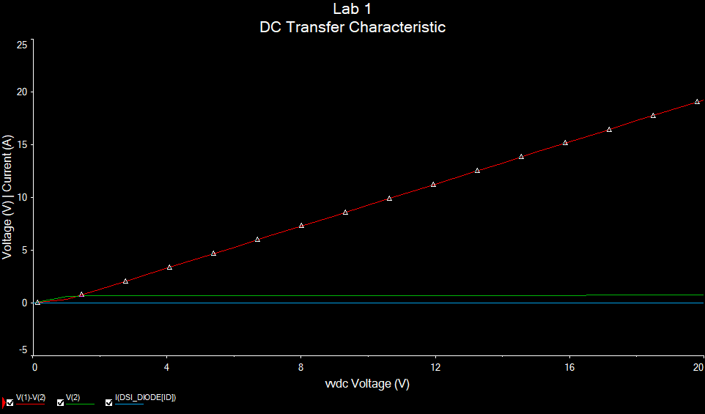

Figure – 2: Graph of the I-V characteristic diode

**Result Analysis & Discussion:**

In this experiment, we learnt about the I-V characteristics of diodes, we also learnt about the threshold voltage, load line analysis and we’ve also learnt how to use Multisim live and Multisim. Now, while simulating the circuit, we took many values and checked the voltage across the resistor, voltage and current across the diode and noted them in Table – 1. Now from there we can see that the current across the diode is zero until 0.3V and then it was close to zero at 0.5V after that at 0.7V it was 0.1 which means it started rising. So, we can confirm from the table that the threshold voltage is around 0.7V as after that the current across the diode keeps increasing a lot even for a small increment of the voltage source and we can see that in the Graph from Figure – 2 that the (red) line representing the current through the diode was increasing a lot.

**Questions / Answers:**

**1. Taking readings from the data table, draw curve of diode in a graph paper with proper scale [x-axis: 0.2 V per unit, y-axis: any suitable range].**

**Answer:**

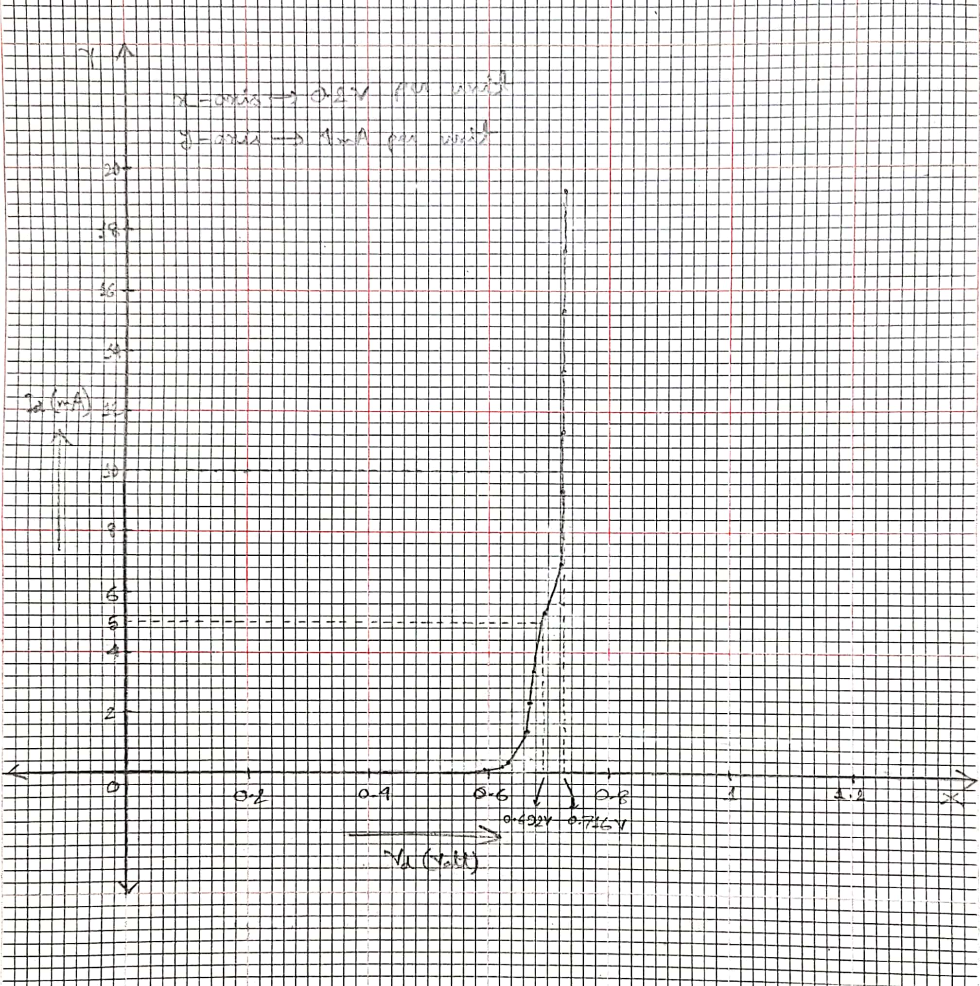

Figure – 3: Graph of the Curve of Diode

**2. What is dynamic and static resistance of a diode?**

**Answer:**

Static Resistance (Rf): The ratio of forward voltage to forward current is the static resistance (Rf) of a P-N junction diode. According to Ohm's Law, static resistance is the usual ohmic resistance. It is a constant at a given temperature and is the ratio of voltage and current.

The ratio of DC voltage applied across the diode to the DC current or direct current passing through the diode is also known as static resistance.

Rf refers to the resistance provided by a p-n junction diode when it is forward biased.

Dynamic Resistance (rf): When AC voltage is delivered to a P-N junction diode, dynamic resistance is defined as the little change in forward voltage to small change in forward current at a specific operating point.

Non-ohmic materials' resistance is measured using dynamic resistance. The ratio of a differential change in voltage to a differential change in current is what it's called. For a non-ohmic conductor, dynamic resistance is a function of the current (or voltage) passing through the material.

Charge carriers or electric current do not flow in a single direction in an AC circuit. It has the ability to flow both forward and backward.

The ratio of change in voltage to change in current is also known as dynamic resistance. It is denoted as rf.

**3. From the graph, find Vd for corresponding values of Id = 5 mA and Id = 10 mA and calculate the static resistance.**

**Answer:**

From the graph,

When, Id = 5 mA

Vd = 692mV

And when, Id = 10 mA

Vd = 716 mV

For Id = 5 mA and Vd = 692mV,

Static Resistance, Rf= Vd/ Id= 692mV / 5mA = 138.4 Ω

For Id = 10 mA and Vd = 716mV,

Static Resistance, Rf= Vd/ Id= 716mV / 10mA = 71.6 Ω

**4. Considering Vdc = 2 volt, find the load line (Showing all calculations).**

**Answer:**

Applying KVL across the circuit,

2 - 1000 Id - Vd =0

Id = -(10^-3) Vd +2 * 10^-3 (Load Line)

Here, Id =y and -(10^-3) Vd = mx and 2 * 10^-3=c

For y intersect,

Taking, Vd=0,

Id = 2*10^-3 = 2mA

For x intersect,

Taking Id = 0,

Vd = 2V

**5. Draw the load line in the curve of diode and find Q-point.**

**Answer:**

Here the Q-point is 0.67mV, 1.35mA

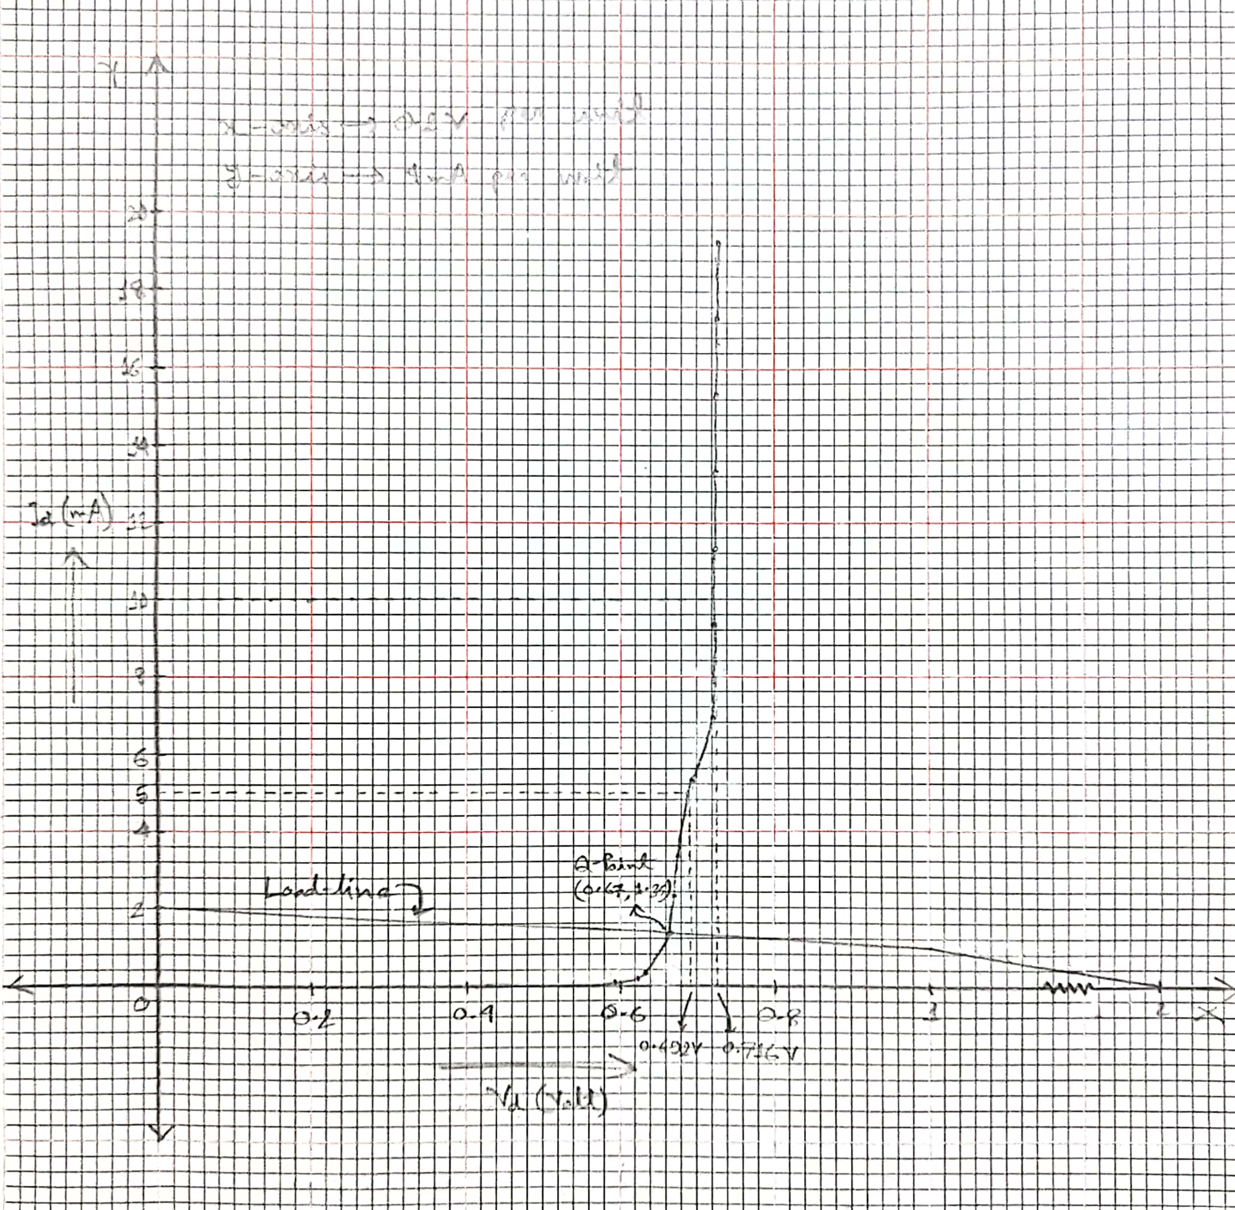

Figure – 4: Graph of the Load-line in the Curve of Diode

Here, because of space shortage we drew the load line as usual until 1 volt with proper scaling and then shorted the line to 2 volt.

**Contributions:**

|  |  |
| --- | --- |
| **Name & ID** | **Contribution** |
| Md. Rifat Ahmed – 1931725042  **(Report Writer)** | Circuit Diagram, Data & Table, Graph, Result Analysis & Discussion, Attachment |
| Yusuf Abdullah Tonmoy - 1620456042 | Questions/Answers |
| Md Kawser Islam - 1912296642 | Theory, Equipment List |

**Attachment:**

**Task: 01**

|  |  |  |  |
| --- | --- | --- | --- |
| **Vdc**  **(volt)** | **Vd**  **(volt)** | **VR**  **(volt)** | **Id = VR / R**  **(mA)** |
| 0.1 | 0.1V | (0.1-0.1)V = 0V | 0 mA |
| 0.3 | 0.3V | (0.3-0.3)V = 0V | 0 mA |
| 0.5 | 0.498V | (0.5-0.498)V = 0.002V | 0.002 mA |
| 0.9 | 0.622V | (0.9-0.622)V = 0.278V | 0.278 mA |
| 1 | 0.629V | (1 -0.629)V = 0.371V | 0.371 mA |
| 3 | 0.677V | (3-0.677)V = 2.323V | 2.323 mA |
| 6 | 0.698V | (6-0.698)V = 5.302V | 5.302 mA |
| 9 | 0.710V | (9-0.710)V = 8.290V | 8.290 mA |
| 10 | 0.713V | (10-0.713)V = 9.287V | 9.287 mA |
| 14 | 0.722V | (14-0.722)V = 13.278V | 13.278 mA |
| 17 | 0.727V | (17-0.727)V = 16.273V | 16.273 mA |
| 20 | 0.732V | (20-0.732)V = 19.268V | 19.268 mA |

Table - 01

**Task: 02**

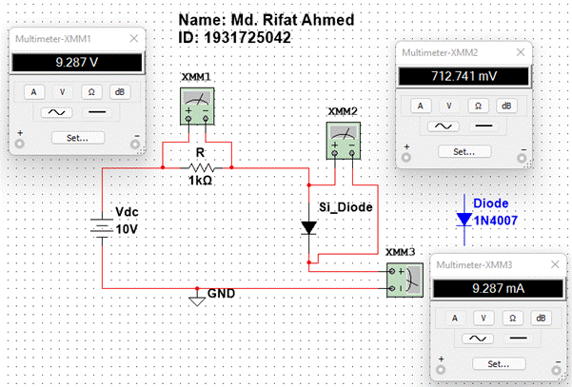

Simulation

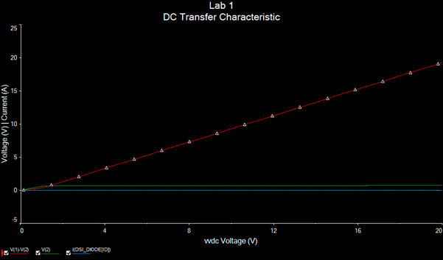

Graph

**References:**

1. [diode | Definition, Symbol, Types, & Uses | Britannica](https://www.britannica.com/technology/diode)

2. [Diode resistance - Static, dynamic and reverse resistance (physics-and-radio-electronics.com)](https://www.physics-and-radio-electronics.com/electronic-devices-and-circuits/semiconductor-diodes/dioderesistance-staticresistance-dynamicresistance.html#:~:text=The%20dynamic%20resistance%20is%20the,current%20flows%20though%20the%20diode)

3. [II. P-N Junction - Engineering LibreTexts](https://eng.libretexts.org/Bookshelves/Materials_Science/Supplemental_Modules_(Materials_Science)/Solar_Basics/D._P-N_Junction_Diodes/II._P-N_Junction)

4. [Analysis of DC Load Line and its Significance for Diode (watelectronics.com)](https://www.watelectronics.com/dc-load-line-analysis/)